# Group Name – SegmentFault

# Members

Shamari Southwell, Mengyuan Zhu, Darius Jones, Ishmeet Tuteja, Jibraan Mubeen

# Topic Chosen

Shopping system - Sahara

# Group Coordinator

Shamari Southwell

# Team Roles

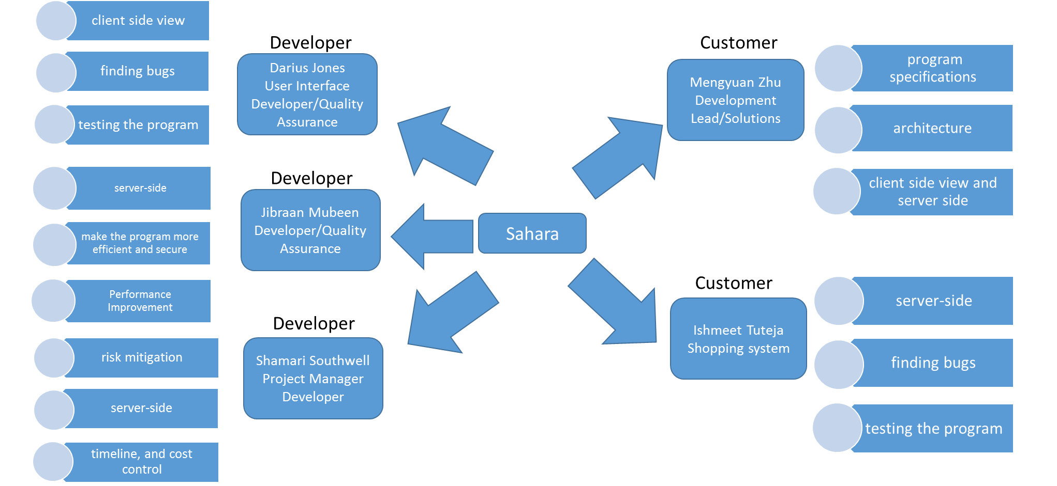

Details:

* **Mengyuan Zhu** – Development Lead/Solutions Architect/Developer
  + Responsible for detailed program specifications creation. Also the first line of support for the developers who need help understanding a concept or working through an issue.
  + Responsible for the architecture and design documents that can be used by the rest of the team to create the solution.
  + Will write code for both the client side view and server side of the application.
* **Shamari Southwell** – Project Manager/Developer
  + Responsible for ensuring consistent reporting, risk mitigation, timeline, and cost control. Also responsible for turning in all project documentation.
  + Will write code for server-side of application.
* **Darius Jones** – User Interface Developer/Quality Assurance (Tester)
  + Will write code for the client side view of the application.
  + Responsible for finding bugs within the program and testing the program before they find their way to the end customers.
* **Jibraan Mubeen** – Developer/Quality Assurance (Performance Improvement)
  + Will write code for the server-side of the application.
  + Responsible for working with Development Lead and coming up with ways to make the program more efficient and secure.
* **Ishmeet Tuteja** – Developer/Quality Assurance (Tester)
  + Will write code for the server-side of the application.
  + Responsible for finding bugs within the program and testing the program before they find their way to the end customers.